***[Title page](https://www.agu.org/Publish-with-AGU/Publish/Author-Resources/Text-requirements" \l "title):***

Assessing natural space exposure within ninety-six global cities

Authors:

Greta K. Martin1, Katelyn O’Dell1, Patrick L. Kinney2, Maria Pescador Jimenez2, David Rojas-Rueda, TBD C40 contributor4, Robert Canales1, George Gray1, Susan Anenberg1

1The George Washington University Milken Institute of Public Health, Washington, DC

2Boston University School of Public Health, Boston, MA

3Colorado School of Public Health, Aurora, CO

4C40 Cities, Washington, DC

# [*Key Points*](https://www.agu.org/Publish-with-AGU/Publish/Author-Resources/Text-requirements#keypoints) *(up to 3. 140 characters each):*

* C40 cities vary greatly in their type, extent, and distribution of natural space, consisting of green and blue spaces.
* Roughly 80% of C40 cities meet at least one Urban Nature Declaration target, while almost half meet both goals.
* The city-wide normalized difference vegetation index (NDVI) value equivalent to achieving Quality Total Cover ranged from 0.352 to 0.563.
* The estimated level of natural space needed to meet the Urban Nature Declaration targets varied across global cities.

# [*Abstract*](https://www.agu.org/Publish-with-AGU/Publish/Author-Resources/Text-requirements#abstract)*(250 words):*

**Background.** Access to urban greenspace (e.g. parks, trees) has been shown to improve physical and mental health by facilitating physical activity and social interaction as well as reducing stress and anxiety. Although less studied, blue space is also hypothesized to provide similar health benefits. In response to such evidence, C40 cities, a global network of mayors committed to climate action, signed an Urban Nature Declaration (UND), setting two 2030 targets. The first target relates to the amount of greenspace within each city and the second to the proximity of green and blue space, or natural space, to the population. **Objective.** In this work, we quantify the extent and distribution of natural space within the 96 C40 cities both in terms of the UND targets and on the scale of the normalized difference vegetation index (NDVI), the most common metric used in epidemiologic studies. **Methods.** We use the European Space Agency (ESA)’s landcover dataset to describe current natural space in terms of the two UND targets. We then use ESA’s Sentinel-2A NDVI data to quantify urban greenspace and the landcover dataset to identify blue space. Finally, we model the relationship between the landcover- and NDVI- based natural space definitions for each city at the 100m grid cell level using linear regressions. **Results.** The city mean NDVI across C40 cities ranged from 0.148 to 0.739 with and overall mean of 0.538. 80% of cities meet the UND target relating to amount of greenspace while nearly half meet the natural space proximity goal. The greenspace quantity regressions models fit well, with a mean R2 of 0.826 (range 0.568, 0.940) and a mean rmse of 0. 077 (range 0.051, 0.109), while the access-based regressions had acceptable fit (mean R2=0.597 range (0.213, 0.820), mean rmse=0.221 (range: 0.213, 0.340). The predicted value of meeting the area-based target had an average city NDVI value of 0.478, while the mean predicted natural space NDVI value of meeting the access-based target was 0.660. **Conclusion:** We develop a methodology for translating the area- and access-based metrics common in policy into the NDVI terms of most epidemiologic studies, allowing the quantification of the health benefits of such policies.

[*Plain Language Summary*](https://www.agu.org/Publish-with-AGU/Publish/Author-Resources/Text-requirements#plainlanguagesummary)*(200 words):*

Studies have shown that people who are exposed to greenspace (e.g. parks, trees) and blue space (e.g. coastline, lakes, rivers) tend to have better physical and mental health. This paper describes the extent of blue and green, or natural spaces, within 96 cities across the globe. The 96 cities included are members of the C40 network, which has set two 2030 goals, one relating to the amount of greenspace within each city and the second to the percentage of the population that has access to nearby green or blue space. In this paper we estimate the level of natural space equivalent to meeting these targets in terms of the most common metric used in health literature. We find that C40 cities vary greatly in terms of the type, amount, and distribution of their natural space. Most C40 cities already have sufficient greenspace according to their stated goal, while less than half have enough natural space near their populations. By creating a translation between the language of the policy goals and the measures used in health literature, we provide a method for quantifying the health benefits of policies to expand urban nature.

# [*Keywords*](https://www.agu.org/Publish-with-AGU/Publish/Author-Resources/Text-requirements#keywords)*:*

0230 Impacts of climate change: human health

1640 Remote sensing

4307 Methods

6620 Science policy

Greenspace, blue space, NDVI, landcover, exposure assessment

# [*Text (including appendices)*](https://www.agu.org/Publish-with-AGU/Publish/Author-Resources/Text-requirements#text)*:*

1. **Introduction**

Urban greenspace (e.g. parks, tree-lined streets) is associated with health benefits, including increased physical activity, social interaction, sunlight and microorganism exposure, and reduced heat, air pollution, and noise exposure (de Keijzer et al., 2019; Garrett et al., 2020; Gascon et al., 2018; Nieuwenhuijsen et al., 2018; Rojas-Rueda et al., 2019; Schinasi et al., 2019; Twohig-Bennett & Jones, 2018; Yang et al., 2021). Urban blue space, defined as all visible surface water, may also provide similar health benefits, though the evidence is less established (Georgiou et al., 2021).

Several organizations have published guidelines for expanding and enhancing urban nature to reduce climate risk and vulnerability while improving overall health and well-being. The World Health Organization (WHO) recommends a minimum of 0.5 hectares (5,000 square meters) of public greenspace within 300m of a person’s home (*Urban Green Spaces: A Brief for Action*, 2017). With 31 city signatories, C40 cities, an international network of mayors committed to reducing greenhouse gas emissions, established an Urban Nature Declaration (UND) that included two 2030 urban nature targets: 1) Quality Total Cover: “30-40% of total built-up city surface area will consist of green spaces… or permeable spaces”, and 2) Equitable Spatial Distribution: “70% of city population has access to green or blue public spaces within a 15-minute walk or bike ride” (C40 cities, 2021). Some cities have also made individual commitments to expanding urban nature. Within the C40 network, for example, Philadelphia, USA has set a goal of achieving 30% tree canopy cover by 2025 (Kondo et al., 2020); London, England has pledged to become the first “national park city”, with half of its area designated as greenspace (*London Environment Strategy*, 2018); and Medellín, Colombia launched the Green Corridors project from 2016-2019, which planted trees along 20 kilometers of roads and waterways (C40 Cities Climate Leadership Group, Nordic Sustainability, 2019).

Although there is a great diversity in the natural space indicators used in urban policy targets, the health literature is more consistent in the metrics used to characterize greenspace extent and exposure. The most common metric used to quantify greenspace in the epidemiologic literature is the normalized difference vegetation index (NDVI) (Huang et al., 2021). NDVI is a satellite-derived measure that uses visible and near infrared light to quantify the density of vegetation. It ranges from -1 to 1, with higher values indicating healthier, denser vegetation, values near 0 suggesting barren land and negative values marking water, snow and ice (*Measuring Vegetation (NDVI & EVI)*, 2000). The advantages of NDVI are that it can differentiate not only vegetation from built surfaces, but also the health and density of vegetation. Additionally, the NDVI metric has full global geospatial coverage with fine spatial (10m) and temporal resolution (10 days). NDVI also captures smaller scale vegetation, such as tree-lined streets and small parks, which is important in characterizing the amount of greenspace people are exposed to in cities. Key limitations of the NDVI metric are that it does not capture the type, accessibility, or quality of greenspace, which are often considered in urban natural space targets in practice.

Studies examining the health benefits of blue space have employed a wide range of metrics. For example, in a systematic review of 50 studies on the relationship between blue space and health, 17 different measures of blue space were used (Georgiou et al., 2021). Methods for assessing exposure to blue space were divided into four broad categories: measures of the amount of blue space within a given area, distance to blue space, contact with blue space, and visibility of blue space (Georgiou et al., 2021). The most common categories used in the epidemiological literature were measures of the amount of blue space within a geographical area and distance to blue space. However, there is substantial variation within these categories. For example, studies considering the amount of blue space within a given area used buffers ranging in size from 100m to 1.5km and in some cases relied on administrative zones such as zip codes (Georgiou et al., 2021).

To date, there has been no evaluation of C40 cities’ extent of natural space against their UND targets. Part of the challenge of measuring progress towards these targets is that they are framed in broader terms that don’t align well with the natural space metrics used in the health literature. In this paper, we evaluate urban natural space extents against C40’s UND targets using satellite-based metrics of green and blue space. We then convert the natural space targets into a city-specific metric that can be compared directly to the greenspace metric used in the health literature, NDVI. We conduct our analysis for all 96 cities in the C40 network, which account for a total of 291 million residents, 1,747 megatons of greenhouse gas emissions and a gross domestic product of nearly $11 billion (Hoornweg et al., 2020). The crosswalk we create between the UND targets and estimates of natural space on the NDVI scale makes it possible to quantify the health gains from achieving these targets. The methods we use to convert these goals to the NDVI scale could also be applied to evaluate progress towards additional policy targets aimed at expanding the amount of and access to urban nature.

1. **Methods**

We characterized each of the 96 C40 cities’ extent and distribution of natural space using satellite derived NDVI and landcover data (Fig. 1). We developed and analyzed two natural space metrics considering: 1) greenspace only, and 2) total natural space, inclusive of both green and blue spaces. We then evaluated each city’s current extent and distribution of natural space against both UND targets, Quality Total Cover (focused on greenspace) and Equitable Spatial Distribution (focused on total natural space). Finally, we regressed the natural space estimates using landcover and NDVI data to estimate the city-specific level of natural space needed to reach each UND target on the NDVI scale. The regression inputs, in map format, is shown in Appendix B for an example city, Washington, DC.

**Figure 1.** Methods data analysis flowchart. The arrows represent processes and the squares datasets. Regression models are shown with red arrows. The colors indicate the spatial resolution of the data. Orange boxes show 10m resolution, blue 100m resolution, and green boxes city-level datasets.

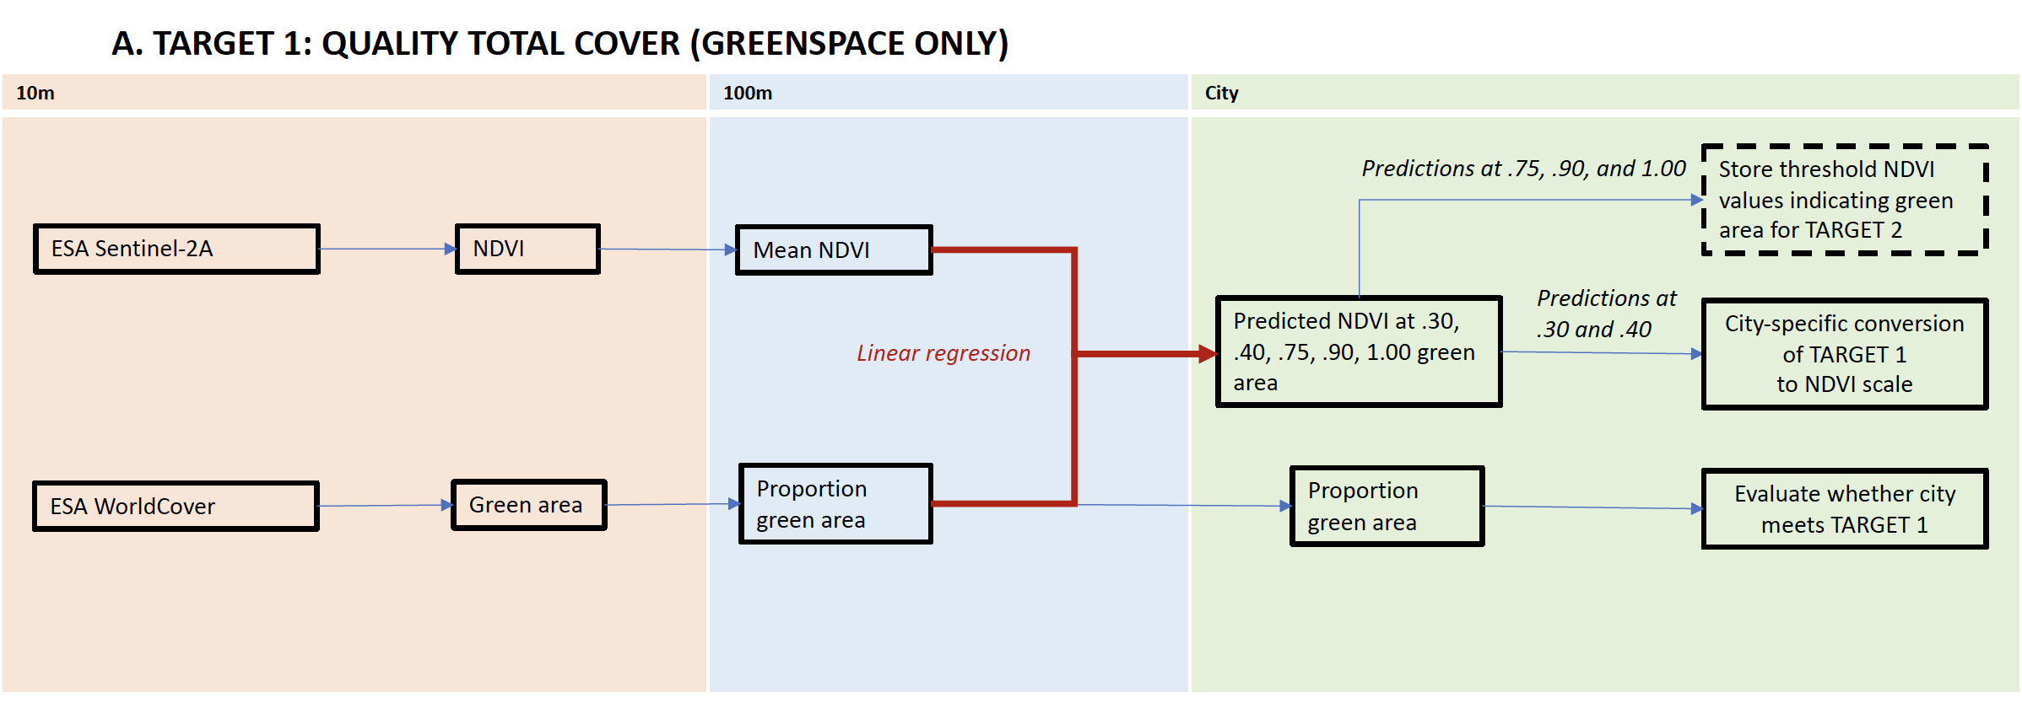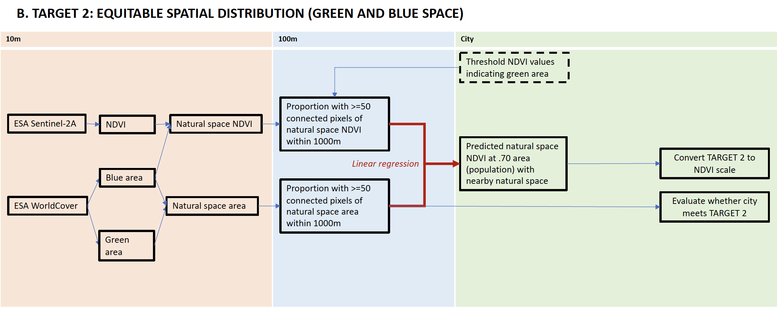

**2.1. Characterizing urban natural space.** To characterize greenspace for each city, we used two global, 10m x 10m gridded datasets for 2020: (1) the European Space Agency’s (ESA) Copernicus Sentinel-2A satellite images (ESA, 2020) to calculate NDVI, and (2) land classifications from the ESA’s WorldCover data set (Zanaga, Daniele et al., 2021).

To estimate greenspace extent using NDVI, we first calculated NDVI using the near infrared (‘B8’) and visible light (‘B4’) bands (Equation 1; Rouse et al., 1974).

$NDVI=(NIR-VIS)/(NIR+VIS)$, (1)

where NIR is near infrared and VIS is visible light. Following previous studies (Corbane et al., 2020; C. Huang et al., 2021; Lindsay et al., 2022; Pericak et al., 2018; Sonia et al., 2022; You et al., 2021), we then selected the greenest value (highest NDVI) from all the 2020 images for each pixel to eliminate cloudy pixels and capture the greenest season across cities in the Northern and Southern hemispheres.

We separately created a binary definition of greenspace using land classifications. We included seven of the 11 land cover classifications in the 2020 ESA WorldCover dataset: trees, shrubland, grassland, cropland, herbaceous wetland, mangroves, and moss and lichen. We excluded the other four categories: built-up, barren/sparse vegetation, snow and ice, and open water.

In both our NDVI- and landcover-based definitions of natural space, which include both greenspace and blue space, we used the ESA WorldCover classification of “open water” to identify surface water at the 10m pixel level. We combined the landcover water classification with NDVI by assigning water pixels a value of 1, equating blue space with the highest possible NDVI value. In the rare case (N=204, <0.0001%) where pixels were not identified as water by the landcover dataset but had a negative NDVI value indicative of clouds or water, they were also considered blue spaces. For the landcover-based definition of natural space, we simply included any open water pixel in the binary classification of natural space.

**2.2. Characterizing urban population and spatial extent.** As the Equitable Spatial Distribution target relates the existence of natural space to the urban population, we assessed each city’s population distribution for this target. We used 100m gridded world population estimates for 2020 from WorldPop (Bondarenko, Maksym et al., 2020). We included only the population aged 20 years and older, as most studies exploring associations between greenspace and health outcomes have been limited to adult populations.

We defined the spatial bounds of each city using the Global Human Settlement Urban Centre database (GHS-UCDB) (European Commission. Joint Research Centre., 2019). The GHS-UCDB uses population data and built-up surface area to define city bounds that correspond to where concentrated populations actually live, rather than administrative bounds. We conducted a sensitivity analysis using self-defined urban bounds from C40 Cities to see how the definition of the urban area impacts estimated natural space extent and urban nature targets (Supplemental data).

**2.3. Evaluating performance against UND targets.** We used the landcover-based greenspace and natural space datasets to compare present-day levels of urban natural space to both UND targets, since the targets are not phrased in terms of NDVI.

**2.3.1. Evaluating performance against Quality Total Cover.** We used our landcover definition of greenspace to evaluate urban performance against the Quality Total Cover target, since it does not include blue space. While the UND target language allows for “permeable surfaces” as well as greenspace, we have only included greenspace in our definition. We aggregated this binary dataset, where each native 10m pixel was classified as greenspace or not, to the 100m resolution by taking the area-weighted mean, with each new 100m pixel representing the percentage of 10m pixels that were classified as green area (Fig. 1 Panel A). We then took the mean of this dataset to evaluate the city-wide proportion of green area.

**2.3.2. Evaluating performance against Equitable Spatial Distribution.** As opposed to the Quality Total Cover target, we used the natural space dataset to evaluate performance against the Equitable Spatial Distribution target, since the latter considers the proximity of the population to both green and blue space. For each city, we first identified areas with sizable, contiguous natural space extents to exclude most private lawns and gardens, since the Quality Total Cover target calls for population proximity to *public* green or blue space. Without another source from which to derive the minimum natural space area that can reasonably be considered public, we used a threshold value of 0.5 hectares (5000 m2), the WHO definition of universal access to greenspace (*Urban Green Spaces: A Brief for Action*, 2017). We then created 1000m buffers around each 10m native pixel and flagged whether there was at least 0.5 hectares of natural space in that zone to capture population access within a fifteen-minute walk or bike, as specified in the Quality Total Cover target. We chose this distance based on The Federal Highway Administration guideline that the average person can walk 1,080 meters in fifteen minutes (Turner, S., Sandt, L., Toole, J., Benz, R., & Patten, R., 2006). While the average cyclist can travel farther, we chose to focus solely on walking for a more inclusive definition of access, as cities vary greatly in cycling infrastructure, bike ownership, and bike comfortability. Next, we aggregated this dataset to the 100m resolution, using the same mean reducer as the Quality Total Cover target. The result was a 100m resolution dataset where each grid cell represents the percentage of area within that pixel that has access to 0.5 hectares or more of natural space within a 1000m buffer, or fifteen-minute walk (Fig. 1 Panel C). In a final step, because the Equitable Spatial Distribution target is dependent on the spatial distribution of the population, we multiplied the green and blue landcover data by the population living in the corresponding grid cell to determine the proportion of the population across the city with proximity to natural space.

**2.4 Converting UND targets to the NDVI scale.** In addition to evaluating each city’s existing natural space against the UND targets using the landcover datasets, we translated the UND targets into the NDVI scale for compatibility with the existing health literature.

**2.4.1. Converting Quality Total Cover to the NDVI scale.** For the Quality Total Cover target, which focuses on greenspace, we aggregated the 10m NDVI dataset to the 100m resolution, so that each 100m pixel represents the area weighted mean NDVI of the 10m pixels within it (Fig. 1 Panel B). We then fit ordinary least squares (OLS) models, regressing the proportion green area from 2.3.1. on the corresponding NDVI value in each 100m grid cell, following methods used in a health impact assessment of Philadelphia’s tree canopy goals (Kondo et al., 2020). We fit separate regression models for each of the 96 cities, to account for differences in local climate and greenness. Finally, we used these models to predict the NDVI value associated with 30 and 40% green area in each city, corresponding to the minimum target range for Quality Total Cover. Model fit was assessed using the coefficient of determination (R2) and the root mean square error (rmse).

**2.4.2. Selecting threshold NDVI values for classifying pixels as greenspace.** Because the Equitable Spatial Distribution target requires identifying natural space before aggregating to a 15-minute walk buffer zone, we used the regression models from the Quality Total Cover target to set threshold NDVI values above which a pixel would be considered “green.” Using these regression models from 2.4.1., we predicted the NDVI value associated with 75, 90 and 100% green area, which we then used as thresholds to determine green area.

**2.4.3. Converting Equitable Spatial Distribution to the NDVI scale.** To convert the Equitable Spatial Distribution target to NDVI terms, we first set a threshold NDVI value above which a pixel was considered greenspace. We tested three city-specific NDVI threshold values, corresponding to the predicted values of NDVI from the Quality Total Cover regression models where the green area was set to 0.75, 0.90, and 1.00. For this target we used our natural space NDVI dataset, where pixels representing water were assigned a value of 1. Because water pixels were assigned the highest value of NDVI, water pixels were always included, regardless of the chosen threshold. Next, we paralleled the process used for the landcover dataset, flagging 10m pixels with sizable natural space areas of 0.5 hectares or more within a 1000m buffer. We then aggregated this binary dataset to the 100m resolution, using an area-weighted mean reducer. Finally, we regressed the landcover-derived proportion of area with access to natural space within a 1000m buffer on the NDVI-based natural space dataset. Model fit was assessed using the coefficient of determination (R2) and the root mean square error (rmse).

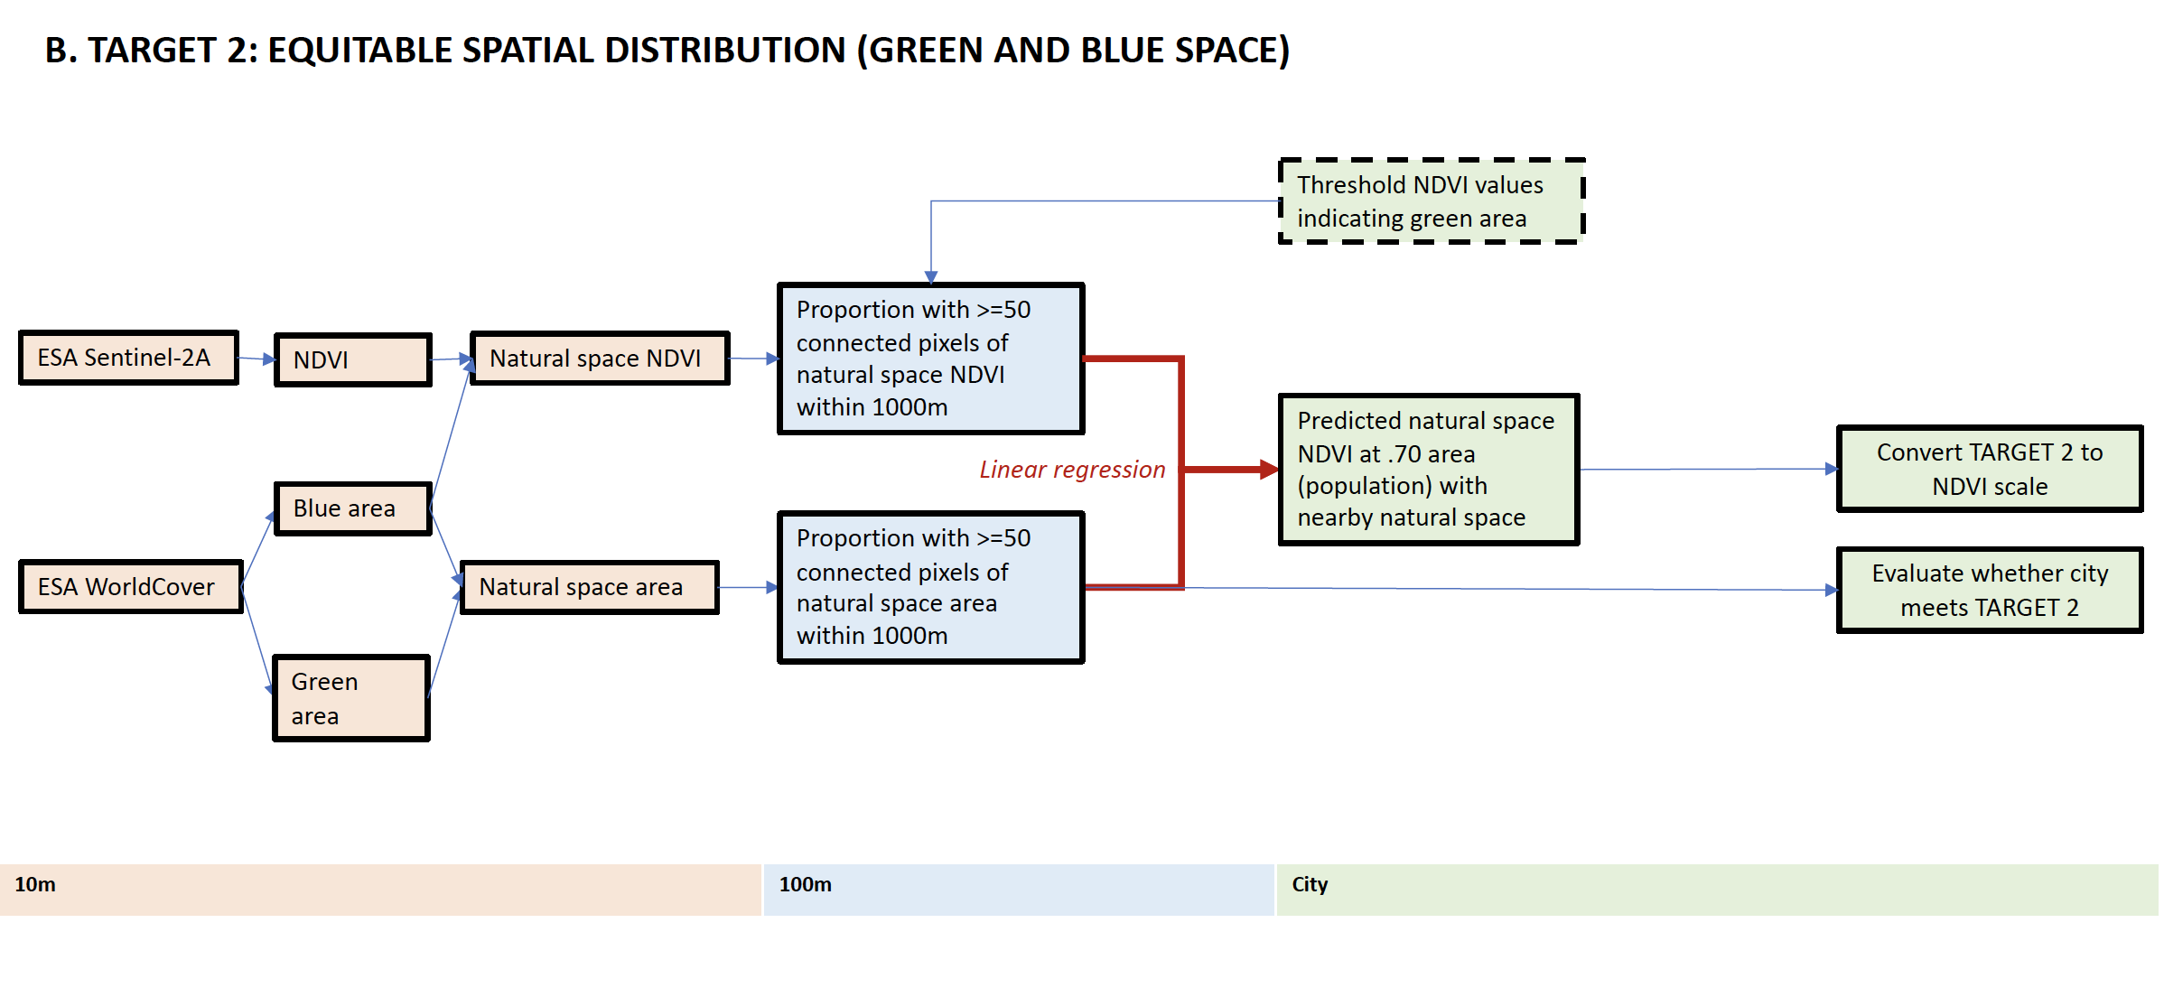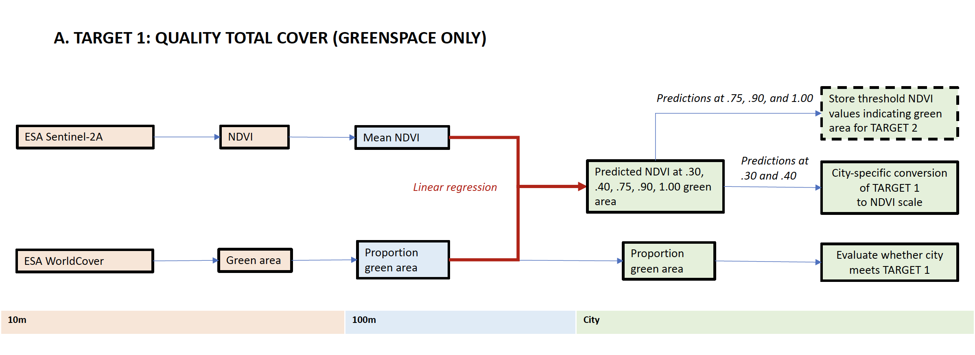

1. **Results**

**3.1. Extent of natural space across C40 cities.** Cities vary greatly in their extent and distribution of greenspace (Fig. 2, Appendix C). The overall city mean NDVI across C40 cities was 0.538 and ranged from 0.148 in Lima, Peru to 0.739 in Dhaka, Bangladesh (Appendix A). Even for cities with similar median NDVI values, their distribution of greenspace can differ dramatically. For example, Hanoi, Auckland, and Jakarta have a median NDVI of approximately 0.62 while their distribution of grid cell values is very different (Fig. 2 Panel C). European and North American cities tended to have higher median NDVI values and Latin American cities tended to have lower ones. However, the intra-regional variability was more substantial than regional differences. The extent of natural space increased in most cities when considering the natural space NDVI dataset, which includes blue space (Supplemental Figure C2). The overall city mean natural space NDVI was 0.569 (range: 0.181-0.816). Adding blue space had the biggest effect for Venice, Italy, where the inclusion of water resulted in a natural space NDVI that was 87% greater than its greenspace-only NDVI value. Dakar, Senegal and Dubai, United Arab Emirates also gained substantial natural space with the inclusion of water, with natural space NDVI values increasing by over 40%. Despite this overall trend, there were six C40 cities whose NDVI value increased by less than 0.1% when blue space was considered: Addis Ababa, Ethiopia, Quito, Ecuador, Amman, Jordan, Tshwane, South Africa, Guadalajara, Mexico, and Nairobi, Kenya (Appendix A).

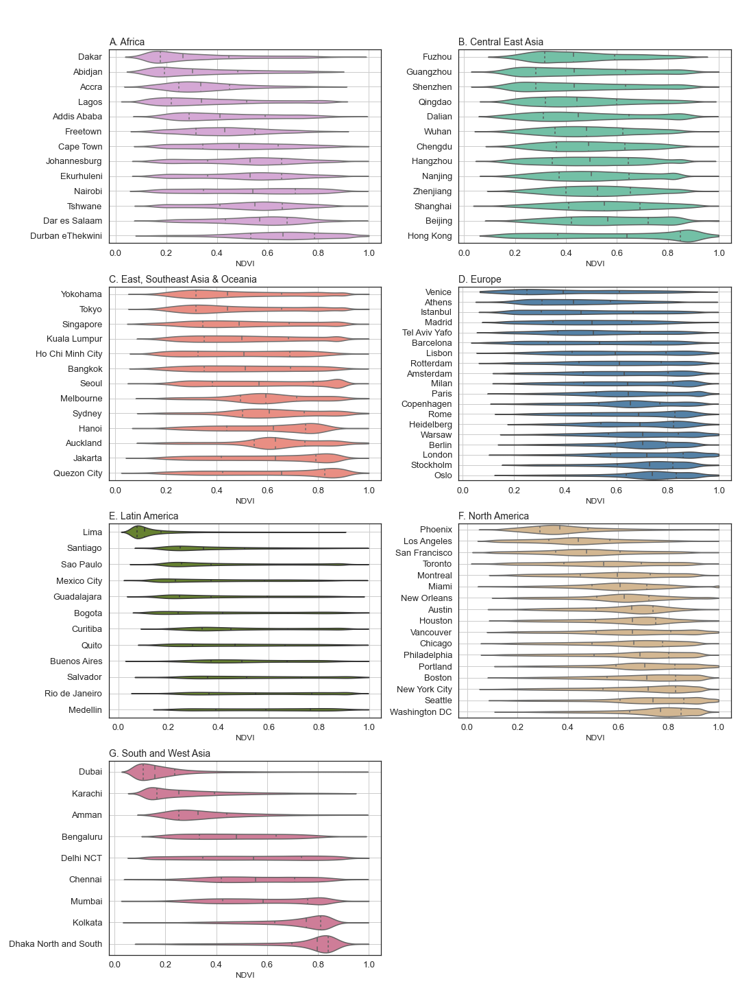Figure 2. Distribution of maximum 2020 Normalized Difference Vegetation Index (NDVI) values for each 100m pixel in C40 cities within each world region. Quartiles of NDVI are shown by vertical lines. These distributions do not include blue space.

The city mean proportion of green urban area was 0.427. Measuring greenspace this way resulted in more extreme values, ranging from a city-mean of 0.031 in Lima, Peru to 0.806 in Dhaka, Bangladesh. Despite averaging the 10m native pixels to the 100m resolution in this dataset, the distribution of pixel values remained highly clustered near 0 and 1 (Supplemental Figure C1). While the city mean green area tended to be lower than NDVI, the relative order of greenness between cities remained fairly consistent (Fig. 2 and Supplemental Data Fig. 2). Adding blue space to this measure increased the mean proportion of green or blue urban area to 0.464 (range: 0.068-0.816). Including water had more dramatic effects on the proportion of green urban area than NDVI. The addition of blue space increased this metric by almost 300% in Dubai, United Arab Emirates, nearly tripled the natural space value in Venice, Italy, and more than doubled it in Lima, Peru. The same cities that were largely unchanged by the addition of water to the NDVI metric, saw a similarly modest increase in the landcover metric. All but Guadalajara, Mexico, whose value increased by 0.14%, experienced a less than 0.1% increase.

Figure 3. Green and natural space across C40 cities by region in 2020, quantified using metrics comparable to the two Urban Natural Declaration targets. Each of the scatter points represents a city within that region. The light and dark green vertical lines in Panel A mark the Quality Total Cover goal range (0.30-0.40 of urban area is greenspace) while the blue line in Panel B represents the Equitable Spatial Distribution target (0.70 of population with access to blue or greenspace within a 15-minute walk).

**4.2. Performance on UND targets.** Many C40 cities already meet the standard of one or both UND targets (Fig. 3). Seventy-seven (80%) of cities meet the lower end of the Quality Total Cover target, with at least 30% of their urban area designated as greenspace. At least 60% of cities in all regions met the 30% Quality Total Cover target, including all 13 cities in the East, Southeast Asia & Oceania region (Fig. 3). Nearly 90% of North American and European cities met the higher end of this target range, with 40% or more greenspace. Despite these regional trends, there was substantial intra-regional variation in performance on the Quality Total Cover target.

Fewer cities met the Equitable Spatial Distribution target; 70% of the population has access to green or blue space within a 15-minute walk in 45 C40 cities. There was considerable inter- and intra-regional variation on this target. Over ¾ of North American C40 cities met the Equitable Spatial Distribution target, compared to less than 10% of C40 cities in the Latin American and African regions. Less than 20% of the population has access to natural space within a 15-minute walk in Lima, Peru, Karachi, Pakistan, and Dubai, United Arab Emirates. In contrast, there are 18 C40 cities, representing four of the seven regions, where over 90% of the population has nearby natural space. All cities that met the Equitable Spatial Distribution target also met the Quality Total Cover target, resulting in a total of 45 cities that met both UND targets.

**4.3. Converting UND targets to the NDVI scale.** After comparing each city’s existing levels of natural space to the UND targets using landcover datasets, we translated these targets into the NDVI scale so that the health benefits of meeting the UND targets may be quantified. For the Quality Total Cover target, we modeled the relationship between the proportion of green area and NDVI in each 100m pixel by running separate linear regression models for each city. These models generally had good fit (Fig. 4 Panels A & B). On average, the models explained 83% of the variance in NDVI, ranging from 57 to 94% for a given city. The root mean square error (rmse) for these models had a mean of 0.077 (range: 0.051, 0.101) across C40 cities. For an average city and pixel, our model’s predicted NDVI values differed from the actual NDVI values by 0.077. We used our models to predict the NDVI value equivalent to achieving the Quality Total Cover target. The mean NDVI representing 30% green area was 0.478 (range: 0.352, 0.565) (Fig. 4 Panel C). At 40% green area, the mean predicted NDVI was 0.528 (range: 0.428, 0.612). In general, the Quality Total Cover regressions had better fit in cities with more greenspace. Model regressions by region can be found in Appendix C.

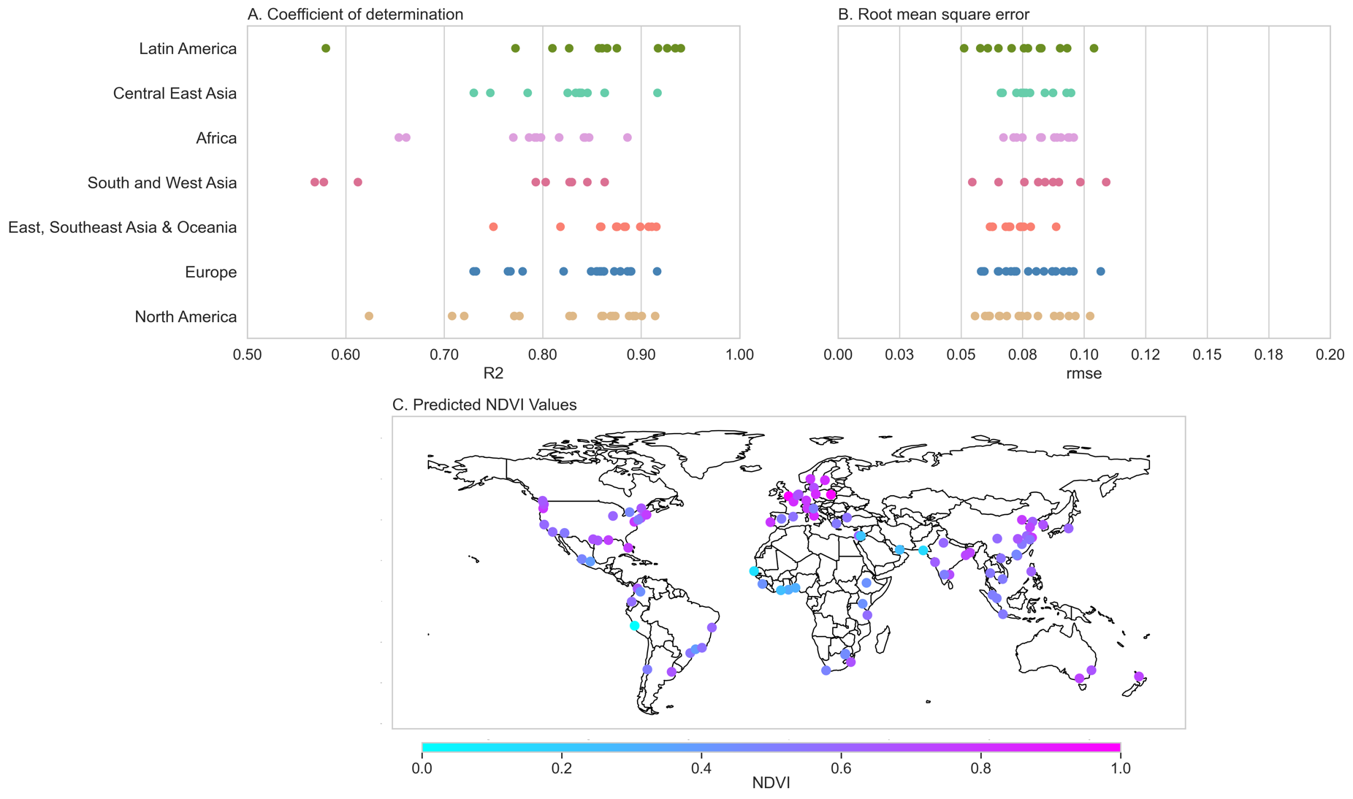Figure 4. Quality Total Cover Model fit statistics and results. The proportion of green urban area was regressed on the NDVI value for each 100m pixel in each of the 96 C40 cities. Each dot represents a city. Panels A and B show the model fit statistics by region. Panel A shows the adjusted R2 value while Panel B shows the root mean square error (rmse). Panel C shows the predicted NDVI value where the proportion of green area is 0.3.

We also used the regression models to predict threshold NDVI values at which or above a pixel would be classified as “green” so that we could quantify the Equitable Spatial Distribution target in NDVI terms. We tested three thresholds: the predicted model NDVI value where the proportion of green area was 0.75, 0.90, and 1.00. Because of the difference in scale between our models (100m) and the classification (10m), we predicted the equivalent NDVI value not just for full green area but two less stringent options as well. We selected the NDVI prediction at 0.75 green area to classify pixels as greenspace, because the fit statistics for the Equitable Spatial Distribution regressions performed best with this threshold. The fit statistics and model predictions using 0.90 and 1.00 proportion green area can be found in the Supplemental Material (Appendix E).

Figure 5. Equitable Spatial Distribution model fit statistics and results. These models regressed landcover-based definitions on NDVI-based definitions of the proportion of each 100m pixel with access to 50 connected pixels of natural space within a 1000m buffer for each of the 96 C40 cities. Each dot represents a city. Panels A and B show the model fit statistics by region. Panel A shows the adjusted R2 value while Panel B shows the root mean square error (rmse). Panel C shows the predicted natural space NDVI value where 0.70 of the area, and thus population, has access to sufficient nearby natural space. Models with poor fit (R2 less than 0.50) are shown with small dots.

The models for the Equitable Spatial Distribution target regressed the proportion of area within a 100m grid cell with access to natural space, as defined by the landcover map, within a 1000m buffer on the proportion of the 100m pixel with access to natural space, as defined by having a natural space NDVI value at or above the threshold, in the same 1000m buffer. These models had a mean R2 across cities of 0.597 (range: 0.213, 0.820) and a mean rmse of 0.221 (range: 0.091, 0.340) (Fig. 5 Panels A &B). We used these regressions to predict the natural space NDVI value equivalent to achieving the Equitable Spatial Distribution target of 0.70 proportion population access to natural space with a 1000m buffer, or 15-minute walk. The average natural space NDVI associated with meeting this UND target was 0.660 and ranged from 0.498 to 0.767 across C40 cities (Fig. 5 Panel C). The Equitable Spatial Distribution regressions tended to fit best when the proportion of the population with nearby natural space was less than 0.90. Model regressions by region can be found in Appendix C.

**4.4 Sensitivity analysis using C40-defined urban extents.** The results of our sensitivity analysis using C40 self-defined shapefiles were similar to those presented above using the urban boundaries as defined by the GHS-UCDB. The average extent of natural space was higher, and the range of city-wide natural space metrics was much larger using the C40 city limits (Appendix A). The larger variation from using the C40 definitions is likely due to the lack of a standardized boundary methodology, unlike GHS-UCDB. Using these definitions, 82 cities met the Quality Total Cover and 43 met the Equitable Spatial Distribution targets. In general, whichever urban definition included more land area had a greater natural space extent across NDVI- and landcover-based measures (Appendix F). The estimated NDVI and NDVI plus water equivalent values were much closer than the estimates of natural space itself (Appendix F).

1. **Discussion**

This work provides the first global assessment, to our knowledge, of both urban greenspace, and a combined measure of urban green and blue space, using two satellite-based datasets. We found that C40 cities vary greatly in their amount, type, and distribution of natural spaces. For some cities, the inclusion of water in the definition of natural space made a substantial impact, in some cases doubling the amount of nature within city bounds. While much of the existing literature on urban nature has focused solely on greenspace, our results show blue space can greatly contribute to urban nature in many cities. We compared existing levels of urban natural space to the C40 Urban Nature Declaration targets and found that most C40 cities already meet one or both targets. Of the 96 C40 cities, 77 (80%) have at least 30% green area while at least 70% of the population has access to green or blue space within a 15-minute walk in 45 cities (47%). Finally, we translated the C40 policy targets to the NDVI scale, linking our natural space exposure assessment to the exposure-response functions found in the health literature. The city-specific equivalent NDVI value to meet the Quality Total Cover target ranged from 0.352 to 0.565 and from the natural space NDVI value for the Equitable Spatial Distribution target ranged 0.498 to 0.767. The translations we provide can be used to quantify the health gains from expanding urban nature.

While a translation between the C40 targets and NDVI is needed to assess health benefits of these goals, the NDVI metric is not without its limitations. First, NDVI relies solely on the greenness of an area, meaning it has no insight into the accessibility or quality of that space, which is relevant for health benefits. Public parks and private golf courses are not differentiated by the satellite. That said, there is some evidence to suggest that even just viewing green and blue spaces can have positive health benefits, such as reducing stress and anxiety and increasing productivity (Kaplan, 1993; Stephen Kaplan & Rachel Kaplan, 1989). Second, there may be forms of nature, that though neither blue nor green, present many of the same benefits as greenspace. For example, desert climates might feature sandy or rocky terrain that can be used for exercise, provide a place to gather with friends and family, and offer natural beauty. A 2022 review of natural spaces outside the “green” and “blue” paradigm looked at landscapes dominated by snow and ice, deserts, and caves and found some evidence that there are health benefits from these environments, which are not well-represented by NDVI (Li et al., 2023). While NDVI is an imperfect measure, it represents the best available science for quantifying greenspace globally.

Beyond NDVI as a metric, there are limitations in our construction of ideal levels of urban natural space. While using the targets set by the C40 cities themselves is valuable for political buy-in, there are some concerns about their appropriateness for such a geographically diverse group of cities. For some, achieving 30-40% green urban area may not be the best standard, or even feasible. For cities with desert climates, such as Phoenix or Dubai, maintaining 30% green area would require high water usages that could be damaging to the environment and health. Additionally, efforts to increase greenspace should be careful to protect disadvantaged communities. Policies to expand urban nature often do so where land is cheapest, leading to “green gentrification,” or increased property values where new parks and greenways are added (Wolch et al., 2014). Further, the Equitable Spatial Distribution target does not capture who has access to urban nature; the 70% that have access may or may not fairly represent the larger population. Lastly, existing methods for combining green and blue space are limited (Mizen et al., 2019). In this paper, we have developed a NDVI plus water metric to allow for the inclusion of water, by assigning in the highest value of NDVI, 1. While there is evidence to suggest that exposure to blue space provides similar benefits to that of greenspace, the relative strength of this relationship is unknown.

Furthermore, there are some limitations to our method of translating the C40 targets into NDVI terms. First, we used the greenest pixel from 2020 to measure greenspace as our study population of cities have very different seasons, following methods from previous works (Corbane et al., 2020; C. Huang et al., 2021; Lindsay et al., 2022; Pericak et al., 2018; Sonia et al., 2022; You et al., 2021). However, this decision could exaggerate the greenness of a city, though this overestimation is likely non-differential across cities. Our city-wide estimates of NDVI were consistently higher than the 1km population-weighted peak NDVI values reported for 2020 in a recent study of 1,000 global cities (Stowell et al., 2023), with a mean difference of .08 and standard deviation of .02). However, our estimates had a strong correlation of 0.96 with the Stowell et. al measure, despite the difference in resolution and population weights. Second, we have used a 1,000m buffer to approximate a 15-minute walk for the Equitable Spatial Distribution target. This may ignore some realities on the ground that impede or facilitate mobility, for example the absence or existence of sidewalks, streetlights and other infrastructure that effects walkability. Third, while we were able to achieve good prediction from our Quality Total Cover regression models, some of the Equitable Spatial Distribution models had R2 values under 0.5, which could affect the accuracy of our NDVI values for that target. Despite these limitations, we provide a strong framework for converting area- and access-based urban policies into NDVI, facilitating the estimation of health gains from such policies.

Our work provides a pathway to assess the health benefits of urban nature policies, though further work is needed in a few key areas. Methods for combining green and blue space are lacking. This is in part due to inconsistencies in the way that blue space has been operationalized in health literature (Georgiou et al., 2021). Further research to quantify the effect of urban blue space on health outcomes as well as innovation in jointly capturing the health impact of access to urban natural space is needed to provide better information to urban planner and policy makers. Furthermore, while we were able to model the relationship between the amount of greenspace and NDVI, regression models did not capture the relationship between the access-based target and our NDVI plus water metric. Additional methods for converting access-based measures into NDVI terms would help to quantify the associated health benefits of such policy aims. Lastly, in this paper we focus on C40 cities, however this work could be expanded to global urban areas more broadly. These advances could help ensure policymakers have the tools and information needed to advocate for future natural space goals.

In this paper, we translate C40’s Urban Nature Declaration targets into NDVI terms, providing a path to estimate the health, and subsequent economic, benefits that could be achieved by meeting these targets. These analyses could be used to support urban planning, or climate policy with green-space co-benefits. The specific conversions created in this work are made for the 96 C40 member cities, representing diverse cultural, political, and climatic contexts. These conversions could be applied to a health impact assessment of the achieving the targets set by the Urban Nature Declaration. This could provide useful information for C40 cities municipal decision makers and increase political will for expanding urban natural space.

# [*Acknowledgments and Data Availability Statement*](https://www.agu.org/Publish-with-AGU/Publish/Author-Resources/Text-requirements#acknowledgments)*:*

This work is funded by the Wellcome Trust (grant no: 216075/Z/19/Z) and The George Washington University Milken Institute of Public Health. We appreciate helpful discussions with the C40 Cities Air Quality and Co-benefits teams.

Data from the European Space Agency’s (ESA) WorldCover and Sentinel-2A datasets (Chander et al., 2009; Zanaga, Daniele et al., 2021) were used to quantify urban natural space. All data are publicly available and accessed through Google Earth Engine (Google Earth Engine, n.d.-a). Data analysis and figure creation were done in Spyder 5.0 (Pierre Raybaut, 2009) and Stata 14.0 (StataCorp, 2015).

# [Supporting information](https://www.agu.org/Publish-with-AGU/Publish/Author-Resources/Text-requirements" \l "supportinginformation)(e.g., graphs)

**Supplemental Data.**

**Appendix A: City-level summary data.**

**Supplemental Data A1.** City-level natural space and population measures as well as target and model estimations using Urban Centre Database (UCDB) urban bounds.

One city, Jakarta, was missing age- and sex-specific gridded population data. For this city, we use WorldPop gridded total population data multiplied by the proportion of the Indonesian population that is 20 years or older. The medium variant projection from the United Nations was used to estimate the population pyramid of Indonesia (World Population Prospects 2022, 2022).

[Excel file]

**Supplemental Data A2.** City-level natural space and population measures as well as target and model estimations using C40 self-defined urban bounds.

One city, Jakarta, was missing age- and sex-specific gridded population data. For this city, we use WorldPop gridded total population data multiplied by the proportion of the Indonesian population that is 20 years or older. The medium variant projection from the United Nations was used to estimate the population pyramid of Indonesia (World Population Prospects 2022, 2022).

[Excel file.]

**Appendix B:** **Methods Figure.**

Supplemental Figure B1. Natural space regression inputs for an example city, Washington, DC, for 2020. Panels A and B show the metrics used to assess the Quality Total Cover target while Panels C and D show the metrics used to assess the Equitable Spatial Distribution target. Panel A is the proportion of green area in each 100m pixel, Panel B the mean 100m normalized difference vegetation index (NDVI), panel C the proportion of the 100m pixel with access to landcover-based natural space within a 1000m buffer, and panel D the proportion of the 100m pixel with access to NDVI-based natural space within a 1000m buffer (using a threshhold of the predicted NDVI value where proportion of green area=0.75).

Appendix C: Regional plots of city natural space distributions.

Supplemental Figure C1. Distribution of 100m green area values for each pixel in C40 cities within each world region. Quartiles of green area are shown by vertical lines. These distributions do not include blue space.

Supplemental Figure C2. Distribution of natural space NDVI 100m values for each pixel in C40 cities within each world region. Quartiles of natural space NDVI are shown by vertical lines.

Supplemental Figure C3. Distribution of 100m green and blue area values for each pixel in C40 cities within each world region. Quartiles of green and blue area are shown by vertical lines.

***Appendix D. Regional composite figures show the results of the regression models.***

Supplemental Figures 5-12 show density scatter plots of the mean NDVI and mean proportion green area for each 100m pixel of each city in a given region. Supplemental Figures 13-19 show density scatter plots of the proportion of each 100m pixel with access to a minimum of 0.5 hectares of natural space (as defined by meeting a minimum NDVI threshold or higher) within a 1000m buffer and the proportion of the 100m grid cell with natural space (as defined by the landcover dataset) within a 1000m buffer for each city in a given region. All 100m pixel values are displayed as a density scatter, where the lighter the shade of red, the more pixels it represents. The ordinary least squares (OLS) regression lines are overlaid on these scatter plots.

GRAPHS ARE IN PROGRESS

**Appendix E. Equitable Spatial Distribution model fit statistics and thresholds using alternative thresholds for classifying pixels as greenspace.**

These models regressed landcover-based definitions on NDVI-based definitions of the proportion of each 100m pixel with access to 50 connected pixels of natural space within a 1000m buffer for each of the 96 C40 cities. Each dot represents a city. Panels A and B show the model fit statistics by region. Panel A shows the adjusted R2 value while Panel B shows the root mean square error (rmse). Panel C shows the predicted natural space NDVI value where 0.70 of the area, and thus population, has access to sufficient nearby natural space. Models with poor fit (R2 less than 0.50) are shown with small dots.

***Supplemental Figure D1.*** *Equitable Spatial Distribution model fit statistics and predictions using the predicted NDVI value at 0.90 proportion of green area as a threshold for identifying greenspace.*

***Supplemental Figure D2.*** *Equitable Spatial Distribution model fit statistics and predictions using the predicted NDVI value at 1.00 proportion of green area as a threshold for identifying greenspace.*

**Appendix F. Sensitivity analysis using C40 self-defined shapefiles to define the urban bounds.**

We have used the GHS-UCDB bounds for our primary analysis as they are constructed in a consistent manner using information on population density and built-up area. However, we conducted a sensitivity analysis using the urban definitions provided by C40 cities. These self-defined bounds tend to represent a smaller area than those of the GHS-UCDB, though this is not always the case, particularly in Chinese C40 cities. The C40 defined shapes are shown in red and the GHS-UCDB bounds in blue.

***Supplemental Figure F1.*** *Comparison of Global Human Settlement Urban City Database (GHS-UCDB) urban bounds and C40 self-defined city definitions.*

Panels A and C show the estimated NDVI value equivalent of achieving the Quality Total Cover target, or 30% green area. Panel A shows the results of the restricted ordinary least squares (OLS) model while Panel C shows that of the unrestricted model. Panels B and D show the estimated NDVI plus water value equivalent of achieving the Equitable Spatial Distribution target, or 70% area with access to natural space. Panel B shows the results of the restricted ordinary least squares (OLS) model while Panel D shows that of the unrestricted model. Each dot represents a city, with purple dots representing cities in which the Global Human Settlement Urban Centres Database (UCDB) urban definition is a larger area and green dots showing cities for which the C40 urban definition is larger.

**Supplemental Figure F2.** Comparison of estimated Urban Nature Declaration target-equivalent natural space levels by urban boundary definition.

**Supplemental Figure F3.** Comparison of natural space metrics by urban boundary definition.